Linear media vs. hyper media
à Liner media:-
Linear media is a media where there is a designed beginning & linear progression to the end. Some forms of liner media such as

1) Audio tape 2) video tape 3) running movies are organized with this expectation.
à Hyper media:-

Ex:-Audio CD.
It is a media where user cum select next item of interest and is immediately transported to that new location.
à Hyper text: - is a method of representing text in highlighted form, which when clicked display more information to be shown within same page or new page.

HTML: - Hyper text markup language. It is first developed by Tendelson in Xanadu systems. HTML language was initially developed by Tinbelnees in 1990.To create pages over internet we should follow a system or language HTML. HTML is mainly useful to crate web pages. It consists of limited tags. It is designed to display the data mainly to focus on new data (render) looks. Mark up languages is a way of writing layout (decorate) description within documents. HTML is initially defined from SGML (standard generalized markup language)
Meta Language
SGML

HTML CML MML etc

à Data defines another data is called Meta data

CML: - Chemical markup language

MML: - Mathematical markup language.

WML: - Write less markup language.

HTML is a set of elements or tags. HTML document is a text file made of up elements tags are used to markup elements.

à Tags are always represented by < >. Representations of tags are <element name>. Every element is start with ‘<’ symbol. The life of the element can start ‘<’ symbol & end with ‘>’

Ex: - b is the html element
<b> is the called start or begins tag.
</b> this is called end tag.

Simple or text content: - Pair of b element is <b>-------</b>
Content may be image or text or lis. The content between begin <b> tag & end </b>. Here tag is called a text content.

Element content: -
<b>
<i>------</i> // inner tag
</b>

Here b is the element content.

Mixed content: -
<b>
-----------
<i>------</i> // inner tag
</b>

Here b is the mixed content.

Empty content: -
<img>

Here img is empty content.
à In html some elements start with only begin tags.

Ex: - <br> break element tag
<br>------ it is one way of representation
<br\>----- it is two way of representation. It is called without having end tag.

à HTML is a case insensitive language.

<br> is same as <BR>

Browser: - It is client software. That allows user to navigate or move World Wide Web (www) & view or create web pages or html pages are computer screen. Popular browsers are Micro soft Internet Explorer, Mozilla—Linux, Fire fox, Netscape navigation, Opera etc.

à Browser window is divided into mainly 3 types.
1) Title bar 2) Address bar 3) Client area or browser area are also known as current document body.
Title bar is used to declare the title of web pages. Html file address can specifies in to address bar. Client area is used to shown the current area.

Structure of the html document: -

Html document begin with <html> tag & ends with </html> tag.
<html>
</html>

Inside the document we contain head section & body section.

To represent the head section <head> </head>

Title element is a part of a head tag
<title>-----------</title>
Representing the author name is to using Meta tag. The tag can not dependent on the other attribute is called independent tag.
Head section includes some stuff (data) that does not show in client area of browser window. It is useful for writing title & technical information (author name, additionally tools) etc of web page.

Head is not compulsory or must. Body section is compulsory.

To represent the body section <body> -------- </body>
Body section includes that is all show it may text in client area. So we must use in body section.
<html>
<head>
<title> -------- </title>
<body> -------
-----------
</body>
</html>

à 1st version of html is 3.0. Only 12 tags used in that version. 4.1 is the current version of html (no. of tags used). Html 4.1 is equal to xml.

Formal Structure of the html document: -
<! DOCTYPE HTML PUBLIC "-//W3C//DTD HTML 4.0 Transitional//EN"

"http://www.w3.org/tr/html4/frameset.dtd">

W3C: - World Wide Web consortium. It is an Organization.

DTD: - Document type definition.

We write programs in generally note pad in windows platform.

GEDIT, XEDIT to write programs in LINUX.

Only one root directory of LINUX is called home.

URI: - Uniform resource indicator or identifier

URL: - Uniform resource locator
It is basic addressing scheme on the Web. It stores address of source file in Web.

There are 2 ways of URL’S
- Absolute path – complete path
- Relative path

Program: -
<html>
<head>
<title> First program </title>
</head>
<body>
Welcome to students
</body>
</html>

O/P: - Welcome to students

Note: - html document can be extended to update content of a page.
Html removes or ignores white space. Blank space, tag space, empty lines or truncated (removed) in html page. This process is called ‘Reformation’ technique, replacing only one single space.

Pre tag: - It displays text as it is written in note pad

Syntax: - <pre> -------- </pre>
Comments: - Single line comments & multiple line comments starts with <!-- & ends with -->

Ex: - <!—This is comment line -->

Tag attributes: -
Tags can have attributes. Attributes carry more information of tags or html elements. Attribute always comes in name and value pair as sown below.

Attrname =“attrvalue”
Attribute value must be enclosed in single quotation or double quotations. Attribute is always specifies in begin tag of html element.

Syntax:-
<elename attrname=‘attrvalue’>-----</elename>

Bgcolor attribute: -
<body bgcolor=“#rrggbb”>
Bgcolor attribute sets background color of Web page. It represents the color in two ways.
à1) Mention with color code or value (RGB)
In this, 6 Hexa decimal numbers represents red, green and blue to form a color.

à2) Write simply color names
<body bgcolor=“yellow”>

RGB color code for the colors: -
Color Code
Black 000000
Blue 0000ff
Cyan 00ffff
Dark gray 404040
Gray 808080
Green 00ff00
Light gray c0c0c0
magenta ff00ff
Orange ffc800
Pink ff0f0f
Red ff0000
White ffffff
Yellow ffff00

Foreground color: -
<text> It sets color of the page in RGB code or color name.

Ex: - <body bgcolor=“red” text=“white”>
Background attribute: - It specifies an image to background of Web page.
<body background=“D:\Photo's\Bala Krishna\Photo 1.jpg”>

Program: -
<html>
<head>
<title> html page2 </title>
<meta name="author" content="Sudheer">

</meta>
<meta name="tools” content="xhtml, JavaScript, css">
</head>
<body text="green"bgcolor="yellow">
<b> <i>
<p align="justify">
Hai I am Sudheer Reddy. I am studying M.C.A final year in BITS College. <br>

My native place is NAGHI REDDY PALLI in ANANTAPUR. <br>
</i>
</b>
</body>
</html>

O/P: -

<Br> tag: - It is used to breaks the text & displays remaining in next line. It contains only begin tag.

<p>tag: - It is used to start the beginning of the paragraph. It contains both begin & end tags. <p> ----------- </p>

Ex: -
<p align=“right”> à right alignment
<p align=“center”> à center alignment
<p align=“justify”> à both left & right same.
à It changes align attribute of paragraphs with multiple values.

Left \ right \ center \ justify

Left is default value of align attribute.

<b> tag: - It presents text in bold letter (thick).
<b> ---- </b>

Ex: - <html>
<body>
<b> This is in bold </b>
</body>
</html>
O/P: - This is in bold
<i> tag: - It displays text in italic format.
<i> ------- </i>

Ex: -
<html>
<body>
<i> This is in italic </i>
</body>
</html>

O/P: - This is in italic

<tt> tag: - It present text in teletype format.
<tt> -------- </tt>

Ex: -
<html>
<body>
<tt> This is in teletype </tt>
</body>
</html>

O/P: - This is in teletype

<center> tag: - It moves the cursor in new line & display text in center without using <br> tag.
<center> ---------- </center>

It displays text or navigates (means moving) text in center of the page.

Ex: -
<html>
<body>
<center> This is center </center>
</body>
</html>

O/P: - This is center

<u> tag: - It is useful to underline the text.

<u> ------ </u>
Html 4.0 some tags are deprecated (removed). Some browsers are not supported to deprecated tags.

<ins> tag: - It is newly defined tag. It is replace of (old version) <u> tag.
<ins> ----- </ins>

Ex: -
<html>
<body>
<u> This is underline text </u> <br>
<ins> This is also underline text </ins>
</body>
</html>

O/P: - This is underline text
This is also underline text

<s> tag: - It is useful to strike out the text
<s> ------ </s>

<del> tag: - It is newly defined tag. It is replace of (old version) <s> tag
<del> ------ </del>

Ex: -
<html>
<body>
<s> This is made strike out </s> <br>
<del> This is also made strike out </del>
</body>
</html>

O/P: - This is made strike out
This is also made strike out

<blink> tag: - It is used to blinking the text. It does not work in IE (internet explorer). It works in opera or etc...

Ex: -
<html>
<body>
<blink> Hai I am Sunil Kumar Reddy </blink>
</body>
</html>

O/P: - Hai I am Sunil Kumar Reddy

<sub> tag: - sub script tag. It displays the contents (means may be text or image or mathematical formula) in sub script notation.
<sub> ------- <sub>

Ex: -
<html>
<head>
<title> Equations </title>
</head>
<body>
<b> Chemical Formula: </b>

NH<sub> 3 </sub> +H <sub> 2 </sub> → NH <sub> 4 </sub> OH <br>
<b> logarithm equation: </b>
log<sub>10</sub>20
</body>
</html>

O/P: - Chemical Formula: NH ₃ +H ₂ → NH ₄ OH
logarithm equation: log₁₀20

<sup> tag: - super script tag. It displays text or content in super script notation. We use <sup> tag for displaying mathematical equations.
<sup> ------- </sup>

Ex: -
<html>
<head>
<title> Equations </title>
</head>
<body>
2<sup>10</sup>=1024 <br>
(a+b) <sup>2</sup>=a<sup>2</sup>+b<sup>2</sup>+2ab
</body>
</html>

O/P:-2¹⁰=1024
(a+b) ²=a²+b²+2ab

Html headings: - Html provides 6 types of heading tags based on size. They are h1, h2, h3, h4, h5 & h6. The head tag contain both begin tag & end tag.

Ex: -
<html>
<head>
<title> math </title>
</head>
<body>
<h1>P.SUDHEER REDDY</h1>
<h2>P.SUDHEER REDDY</h2>
<h3>P.SUDHEER REDDY</h3>
<h4>P.SUDHEER REDDY</h4>
<h5>P.SUDHEER REDDY</h5>
<h6>P.SUDHEER REDDY</h6>
</body>
</html>

O/P: - P.SUDHEER REDDY

P.SUDHEER REDDY

P.SUDHEER REDDY

P.SUDHEER REDDY

P.SUDHEER REDDY

P.SUDHEER REDDY

The heading tag text takes new line, unless we use <br> tag.
<h1 align=”center”> P.SUNIL KUMAR REDDY </h1>

Justify alignment is not support in to head attribute.

<font> tag: - Font characters (Size, color, style). It always content to attributes. Font tag is dependent tag. It specifies font Characteristics.
<font>-----</font>

Ex: - <html>
<body>
<font> Hai I am SUDHEER REDDY </font>
</body>
</html>

O/P: - Hai I am SUDHEER REDDY

Font size: - Zero is the default font size.
Size attributes: - It specifies relative font size. We have set size on the scale of (range of) 0 to 4. 0 is the default size.

<font size=”+1”> SUDHEER REDDY </font>
Color attribute: - It specifies font text color in RGB code or color name. Black color is the default color.
<font color=”#00ff00”> SUDHEER REDDY </font>
Face attribute: - Font styles are case sensitive. It specifies one font type from list of limited number of font styles.
<font face=”Verdana”> SUDHEER REDDY </font>

Roman, Script, Times New Roman, Helvetica, etc… are of the font styles.

Ex: -
<html>
<body>
<font size=“+2” color=“pink” face=“Verdana”> Hai I am SUDHEER REDDY </font>
</body>
</html>

O/P: - Hai I am SUDHEER REDDY

<marquee> tag: - It is useful to scroll (move) text physically.
<marquee> ------ </marquee>

Ex: -
<html>
<body>
<marquee> Hai I am SUDHEER REDDY </marquee>
</body>
</html>

O/P: - Hai I am SUDHEER REDDY

Direction attribute: - It changes the direction of marquee text with different value. They are left / right / up / down.
<marquee direction=”right”> Sunil Kumar Reddy </marquee>
<marquee direction=”up”> Sunil Kumar Reddy </marquee>
<marquee direction=”left”> Sunil Kumar Reddy </marquee>

Left is the default of direction.

Behavior attribute: -
<marquee behavior=”scroll”> Sunil Kumar Reddy </marquee>
<marquee behavior=”slide”> Sunil Kumar Reddy </marquee>
<marquee behavior=”alternative”> Sunil Kumar Reddy </marquee>
Loop attribute: - It sets number of times that marquee text should be scroll.
<marquee behavior=”scroll” loop=”4”> Sunil Kumar Reddy </marquee>

Ex: -
<html>
<body>
<marquee direction=“right” behavior=“alternative” loop=“5” bgcolor=“green”> Hai I am Sunil Kumar Reddy </marquee>
</body>
</html>

O/P: -

à Tag within another tag is called nested tag. There are 2 types
1) Proper nesting 2) Improper nesting.

In html improper nesting are support but xml has not support.
Proper nesting improper nesting
<b> <b>
----- -----
<i> <i>
----- -----
</i> </b>
</b> </i>

<big> tag: - It displays text it big size. It allows some inner tags. Internet explorer only 3 big inner tags are supported, Mozilla supported into more than 10 inner big tags.

Ex: - <html>
<body>
<big>< big >< big >< big >P.SUDHEER REDDY
</big ></big ></big ></big >
</body>
</html>
O/P: -
P.SUDHEER REDDY
<small> tag: - It displays text it small size. Only one time of small inner tag is supported into internet explorer. Mozilla is more than 3 small tags are supported.

Ex: -
<html>
<body>
<SMALL><SMALL>P.SUDHEER REDDY</SMALL></SMALL>
</body>
</html>
O/P: - P.SUDHEER REDDY

Adding images: - Html supported so many images like .jpg, .jpeg, .gif, when image is a page content.
<img> tag: - It display image as content of page. It content only begins tag. It has empty content. It carries no data. It is dependent element. It has some following attribute.
src attribute: - It represent the URL image file.

Ex: - <html>
<body>
<img src=“d:/photo’s/Picture (1).jpeg”>
</body>
</html>
O/P: -

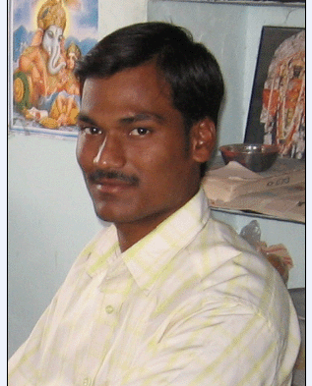
Border attribute: - It sets width of the border around image in pixels. Border default value is 0. It is not compulsory but src is compulsory.
<img src=“d:/photo’s/Picture (1).jpeg” border=“5”>
Align attribute: - Only 2 elements contain left / right not center. Default is left.
<img src=“d:/photo’s/Picture (1).jpeg” align=“right”>
Height & width attributes: - These are useful to set the size of image in the form of pixels, another way is percentages.
<img src=“d:/photo’s/Picture (1).jpeg” height=“200”width=“300”>
Alt attribute: - It gives some alternative text. That is always shown in the plane (space) of the page. It is only work in the new versions. It is always shown the mouse click.
<img src=“d:/photo’s/Picture (1).jpeg” alt=“My Photo”>

Ex: -
<html>
<body>
<img src=“d:/photo’s/Picture (1).jpeg” border=“5” align=“right” height=“45%” width=“20%” alt=“My Photo”>
</body>
</html>
O/P:-
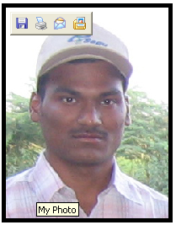

List: - html list represent a group of items of same type. List is 3 types.
- Ordered list
- Unordered list
- Definition list

1) Ordered list: - in ordered list, list items are organized in specific order (manner).
<ol> ------ </ol>
<li> tag: - list item. It is only start tag. End tag </li> is optional.

We can insert items using <li> Tag.
<li> ------- </li>
Type attribute: - It changes the value of behavior. It contains some values. They are 1 / a / A / i / I
<ol type=”a”>

Order list by default start with Arabic numbers like (1, 2, 3 …)
Start attribute: - It is newly defined in xml language. It is not work in old versions. It start order list with number other than 1.
<ol start=”10”>

Ex: -
<html>
<head>
<title> fruits list </title>
</head>
<body>
<u> fruits info </u>
<ol>
<li> mango
<li> banana
<li> grapes
<li> apple
</ol>
<ol type="a">
<li> mango
<li> banana
<li> grapes
<li> apple
</ol>
<ol start="16">
<li> mango
<li> banana
<li> grapes
<li> apple
</ol>
</body>
</html>
O/P: - fruits info
- mango
- banana
- grapes
- apple
- mango
- banana
- grapes
- apple
- mango
- banana
- grapes
- apple

2) Unordered list: - In this list items are not organized (presented) in specific ordered. We can insert the items using <li> tag.
<ul> -------- <ul>
Type attribute: - It changes the value of behavior. It contains some values. They are disk / circle / square
<ol type=”circle”>

By default each unordered list is disk (solid bullets or rounded bullets).

Ex: -
<html>
<head>
<title> veg list</title>
</head>
<body>
<big ><u> veg info</u></big>
<ul>
<li> carrot
<li> tomato
<li> potato
<li> ladyfinger
<li> onion
</ul>
<ul type="circle">
<li> carrot
<li> tomato
<li> potato
<li> ladyfinger
<li> onion
</ul>
</body>
</html>

O/P: - veg info
- carrot
- tomato
- potato
- ladyfinger
- onion
- carrot
- tomato
- potato
- ladyfinger
- onion

3) Definition list: - It is not like ol & ul. It is not a list of items. It organizes a list of definition terms & their descriptions in pairs.
<dl> -------- <dl>
<dt> tag: - definition type tag. It is only start tag. End tag </dt> is optional.

<dt> ------- </dt>
<dd> tag: - definition term definition tag. It is only start tag. End tag </dd> is optional.
<dd> ------- </dd>

These tags are in between of definition list.

Ex: - <html>
<head>
<title> Definition List</title>
</head>
<body>
<dl>
<dt>

HTML
<dd>
Html stands for hyper text markup language. It is designed to render content & mainly to focus on how data looks.
<dt>

XML
<dd>

Xml stands for extensible markup language. It is Meta language.

<dt>

Java Script

<dd>
It is most popular scripting language over internet. It is useful to create DHTML pages, to validate forms at client side.
</dl>
</body>
</html>

O/P: - HTML
Html stands for hyper text markup language. It is designed to render content & mainly to focus on how data looks.
XML
Xml stands for extensible markup language. It is Meta language.
Java Script
It is most popular scripting language over internet. It is useful to create DHTML pages, to validate forms at client side.

HTML Character entities: - Entities are case sensitive. Entities are names or variables as to define shortcuts for some common text. They are two ways.
1) Entities names 2) Entities Number
& entities name; &# entity no;
In markup languages like HTML, XML, we have some special symbols using like <, >, &, “,’ etc are that can not be display directly in web page. Thus we must use entities for displaying special symbols along with text.

The most character entities: -
Result Description Entity name Entity number
Non-braking
Space &nbsp; &#160;
< Less than &lt; &#60;
> Grater than &gt; &#62;
& Ampersand &amp; &#38;
“ Quotation mark &quot; &#34;
‘ Apostrophe &apos; don’t work in IE
¢ Cent &cent; &#162;
£ Pound &pound; &#163;
¥ Yen &yen; &#165;
§ Section &sect; &#167;
© Copy right &copy; &#169;
® Registered
Trademarked &reg; &#174;
x Multiplication &times; &#215;
÷ Division &divide; &#247;

à The purpose of nbsp is without using <pre> tag.

Ex: -
<html>
<head>
<title> Character entities </title>
</head>
<body>
24 &lt; 43 <br>
43 &gt; 24 <br>
22 &amp; 44=88 <br>
&quot; Sunil Kumar Reddy &quot; <br>
User &apos; s <br>
&cent; <br>
&pound; <br>
&yen; <br>
&sect; <br>
&copy; <br>
&reg; <br>
&times; <br>
&divide;
</body>
</html>

O/P:- 24 < 43
43 > 24
22 & 44=88
" Sunil Kumar Reddy "
User’s
¢
£
¥
§
©
®
×
÷

Html table: - To create table we follow 3 steps.

Step1: - Create skeleton (structure) of table using with <table> tag.
<table> <table> // element content.

Step1: - Divide rows into multiple rows using <tr> tag. </tr> is optional.
<tr> </tr> // element content.

Step3: - Select the row & insert data using <td> tag. </td> is optional.

<td> ------ </td>
Border attribute: - Its sets width of the border around the table in pixels. Default size of border is 0.

<table border=“5”>
Border color attribute: - It specifies border color around the table. Default color of border color is white.
<table border=“5”bordercolor=“green”>

Bgcolor Attribute: - It specifies the background color of around a table.
<table bgcolor=“blue”>

Align attribute: - default alignment of table is left.

<table align=“center”>
à For changing the size of the table is two attributes. They are height & width, with only use to pixels not use in percentages.

<table height=“250”width=“300”>

Caption tag: - It sets caption for table. Default behavior of caption is top of the table.

<caption> Emp table </caption>
<th> tag: - Table heading tag. It specify heading to rows & column of the table. </th> is optional.

<th> ------- </th>
Each heading can display center of cell. We can create one empty cell they can not display border default.
Note: - By adding the entity named &nbsp;, the border will be set around empty cell of table.

Ex: - <th> &nbsp; </th>
Rowspan: - It merges two or more cell in row wise (or) horizontal format.

<td rowspan=“4”>
Colspan: - It merges two or more cell in column wise (or) vertical format.
<td colspan=“3”>

Cellpadding: - It provides space in between cell contains.
<td cellpadding=“4”>
cellspacing: - It is also provide space in cells of the table.
<td cellspacing=“5”>

Ex: -
<html>
<head>
<title> Emp info</title>
</head>
<body>
<caption> <ins><h1> emp table : </h1></ins>

<table align="center" border="5"bordercolor="green"
bgcolor="yellow" height="300"width="400">
<tr bgcolor="pink">
<th>
<th> name
<th> id
<th> salary
<th> address
</tr>
<tr>
<td rowspan="4"> employee
<td> Sudheer
<td> 1234
<td> 50,000
<td> atp
</tr>
<tr>
<td> Latha
<td> 1235
<td> 40,000
<td> atp
</tr>
<tr bgcolor="green">
<td> Sailaja
<td> 1236
<td> 30,000
<td> Hyd
</tr>
<tr>
<td> Ishrath
<td> 1237
<td> 20,000
<td> Darmavaram
</tr>
</table>
</caption>
</body>
</html>

O/P: -
emp table :
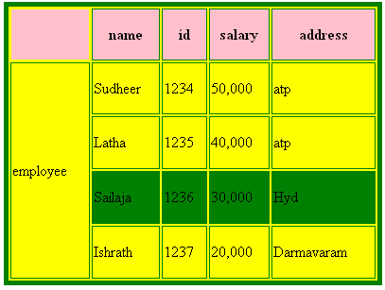

Hyper link: - It is a link that allows user to navigate (jump) from one document to another document quickly. Using hyperlink, to save time complexity.
Hyperlink is highlighted and change to hand symbol, when mouse pointer moves over hyperlink. In html page hyperlinks are defined with text or images that always refer are multi media effort (audio, video), that always refer existing document, internet resource files.

<A> anchor: - It defining link to html document.
<a> -------- </a>.

Ex :-< a href = “URL”>.
href attribute represents the URL of document, that contain between (Text or image). A tag is referred as hyperlink.
Target attribute: - with this, we can define where linked document will be opened. By default the linked document open at some page.
à Every element is containing 2 attributes manually that is called name and id.
<a href=”list.html” target=”new win”>list</a>

Ex:-
<html>
<head>
<title> link </title>
</head>
<body>
<h1> <b> some linked documents available here </b> </h1>
<h3> to see big info click here<a href="big.html"> biginfo </a> <br>
to see Definition List click here <a href="def.html"> def info </a> <br>
to see fruit list click here <a href="fruitslist.html"> fruits info </a><br>
to see marquee info click here <a href= "marquee.html"> marquee info </a><br>
to see Character entities click here <a href="char.html"> Character info </a> <br>
to see math info click here <a href=" math.html"> math info</a> <br>
to see veg info click here <a href="veglist.html"> veglist info </a> <br>
to see image click here <a href="image1.html" target="newwin"> image</a><br>
to see tag info click here <a href="tagexampels.html">tags
<img src="D:\Photoes\Picture (12).jpg" height="4%"width="4%"> </a>
</h3>
</body>
</html>

O/P: -
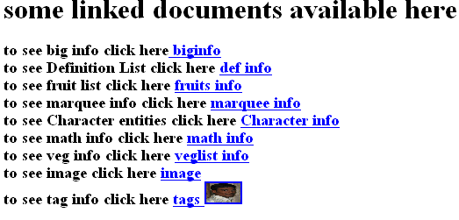
Frames: - with frames we can display more than one document within same browser window, there each document is called frame; which is independent of others.

<Frameset>tag: - collection of frames. It comes two or more frames.
It represents a group of frames. It defines how to divide the window into multiple frames. It contain both begin and end tags. It has alternatively two attributes. They are 1) row 2) columns.

Rows attribute: - it sets number & size of the frames .in % & *.
<frameset rows = “30%, 40%, 20%;*”> </frameset>

These frames are arranged in row wise (Horizontal).
Columns attribute: - it also sets number of frames and size of the frames but frames are arranged in vertical (column wise) wise.
<frameset cols=“30%, 40%, 20%,*”> </frameset>
<Frame>tag: - it converts one document into a frame. </frame>is optional. It is empty content. It is always content in attribute. Source tribute is compulsory of frame tag. The address is converted into frame.
<frameset cols=“30%, 40%, 10%,*”>
<frame src=“URL”> </frameset>
Note: - body tag can not be included in html documents containing frames.

Ex: -
<html>
<frameset rows=“20%,20%,*”>
<frame src=“def.html”>
<frame src=“fruitslist.html”>
<frame src=“char.html”>
</frameset>
</html>

O/P: -

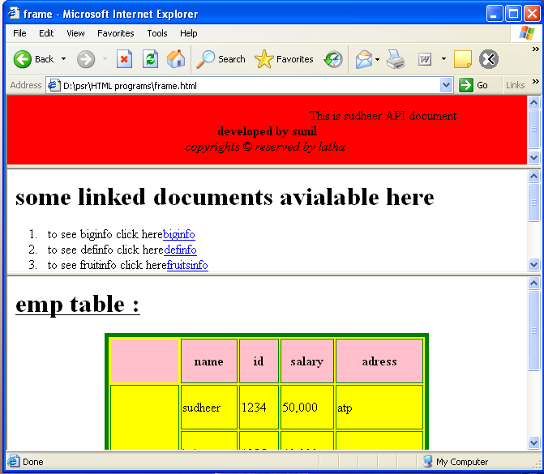

By default the browser resizes the window.

No resize attribute: - It prohibits user from resizing the frame.
<frame src=“char.html” noresize=“noresize”>
border attribute: - It sets width of the border in frames.
<frame src=“char.html” border=“5”>

Border color attribute: - It sets the color of the border in frames.
<frame src=“char.html” bordercolor=“red”>
à Frameset tag allows same frame tags are inner tags.
Name attribute: - It gives a name for the frame where targeted documents or links will be opened.
<frame src=“char.html” name=“------“>

Ex: -
à <html>
<head>
<title> page 1 </title>
</head>
<body bgcolor="red">
<marquee>

This is Sudheer API document </marquee>

<center> <b> developed by Sunil </b> <br>
<i> copyright &copy; reserved by Latha </i>
</center>
</body>
</html>
à <html>
<head>
<title> page 2 </title>
</head>
<body>
<h1><b>some linked documents available here</b></h1>

<ol>
<li>to see biginfo click here<a href="big.html" target="frame3"> biginfo</a><br>
</li>
<li>to see def info click here<a href="def.html" target="frame3"> def info</a><br>
</li>
<li> to see fruit info click here<a href="fruitslist.html" target= "frame3"> fruits
info </a><br></li>
<li>to see marquee info click here<a href="marquee.html" target= "frame3">
marquee info</a><br></li>
<li>to see veg info click here<a href="veglist.html" target="frame3"> veg list info
</a><br></li>
<li>to see emp info click here<a href="emp1.html"target="frame3"> emp1info
</a><br></li>
<li>to see image click here<a href="image1.html"target="frame3"> image </a>
<br></li>
<li>to see tag info click here<a href="tagexampels.html" target= "frame3"> tags
<img src="D:\Photos\Picture (12).jpg" height="4%"width="4%"> </a></li>
</ol>
</body>
</html>

à <html>
<head>
<title> page 3 </title>
</head>
<body bgcolor="green">
<b>
if you click left side events , each one will give into here
</b>
</body>
</html>

à <html>
<head>
<title> frame </title>
</head>
<frameset rows="20%,30%,*">
<frame src="page1.html">
<frame src="page2.html">
<frame src="page3.html">
</frameset>
</html>

O/P: -

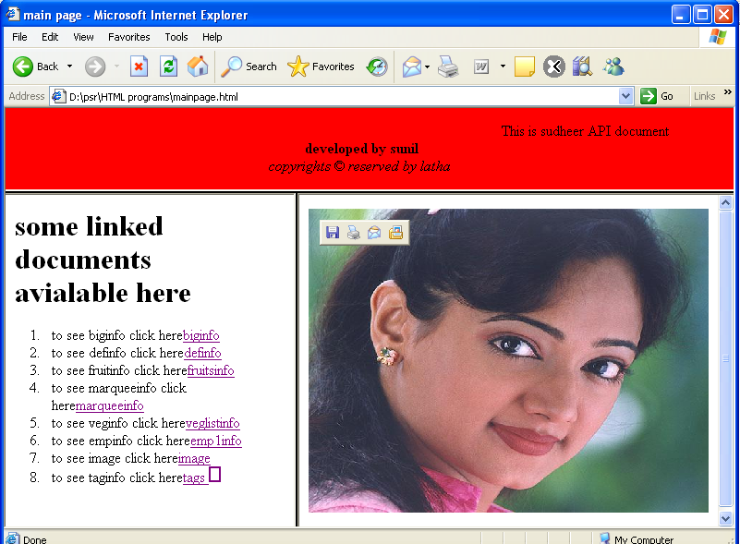

Html Forms: -
1) A form represents blank sheets contain different kinds of elements, like text field, password field, radio button, combo box, etc allow within forms.
2) Form elements allow user to enter some input data
3) Form data can be return to file (.txt, .jsp), submitted to data base or emailed.
4) Thus forms are used as an effective communication between user and servers.

Create forms: -
We can create form html contain one element. It is called <form> tag. It contains both tags.
<form> tag: - It is useful to create one html form or one blank sheet.

Name attribute: - It defines name of the form.
<form name=“emp form”>
Action attribute: - It represents the address of the file in which input data or form data will be stored.

<form name=“emp form” action=“xxx.jsp”>
Method attribute: - (get & post). It defines how to submit input data to the server. There are two ways to do at the tasks.
<form name=“emp form” action=“xxx.jsp” method=“post”>
à When we use get method the input data (query string) or list of parameters & may be submit to the server. But input data will be shown in address bar of browser window.
à When we use post method the input data will be directly submitted to the server & will not be displayed in the address bar of browser window

Create input form fields: -
<input> tag: - It is include in form tag. It creates a 1 input field or form field. It has empty content. It carries no data. It always content with attributes. </input> is optional.
Type attribute: - It represents one type of field from list of limited number of field. It is compulsory.

<input type=“password”>
Name attribute: - It specifies name of the field where the input data can be stored. It is not compulsory.

<input type=“password” name=“Sunil”>
Value attribute: - It is also not compulsory or mandatory (text/password fields). Where we use check boxes, radio buttons, it is compulsory.
<input type=“password” value=“ ”>

Creating a text field: -
Text field is a blank area or single line that allows user to enter any type data.
<input type=“text” name= “ ” value= “ ”>

Size attribute: - It sets width of the text field in pixels.
<input type=“text” size=“30”>
Max length attribute: - It specifies number of character that text field can have.
<input type=“text” maxlength=“5”>

Ex: -
<html>
<head>
<title> Text field </title>
</head>
<body>
<form name="Sudheer" action="Sunil" method="get">
Enter student name:
<input type="text"name="sname" value="" size="30" maxlength = "20">
</form>
</body>
</html>
O/P: - Enter student name: 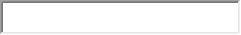
Bottom of Form

Creating password field: - Password field allows user to enter data in password format.
<input type=“password” name=“ ” value= “ ”>

Ex: -

<html>
<head>
<title> Password field </title>
</head>
<body>
<form name="sudheer" action="sunil" method="get">
Enter password:
<input type="password" name="sname" value=""size="10" maxlength="6">
</form>
</body>
</html>
O/P: - Enter password: 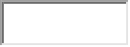
Bottom of Form

Creating hidden field: - Hidden fields accept some data & directly submitted to the server.

Note: - Hidden fields are not displayed in browser window.
<input type= “hidden” name= “ ” value= “ ”>

Ex: -
<html>
<head>
<title> Hidden field </title>
</head>
<body>
<form name="Sdheer" action="Sunil" method="get">
enter student name :

<input type="hidden” name="age” value="28">
</form>
</body>
</html>

O/P: - enter student name:

Creating radio buttons: - Radio buttons let the user to select only one option from list of limited number of options.

<input type=“radio” name=“ ” value=“ ”>
Checked attribute: - We can select one default value from radio button checked attribute.
<input type=“radio” name=“ ” value=“ ” checked=“checked”>

Ex: -
<html>
<head>
<title> Radio buttons</title>
</head>
<body>
<form name="Sudheer" action="Sunil" method="get">
Gender : <input type=“radio” name="sex" value="m" checked>male

<input type="radio" name="sex" value="f">female
</form>
</body>
</html>
O/P: - Gender : male female
Bottom of Form

Creating check boxes: - These fields allow user to select multiple options or deselect from any selection from list of choices or option.
<input type=“checkbox” name=“ ” value=“ ”>

Ex: -
<html>
<head>
<title> Checkboxes </title>
</head>
<body>
<form name="Sudheer" action="Sunil" method="get">
Offered courses : <input type="checkbox" name="crs1"value="C"> C Lang
<input type="checkbox" name="crs2"value="CPP"> CPP Lang
<input type="checkbox" name="crs3"value="java"> Java Lang
<input type="checkbox" name="crs4"value=".net"> .net Lang
</form>
</body>
</html>

O/P: -
Offered courses : C Lang 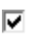CPP Lang Java Lang .net Lang
Bottom of Form

Creating a combo box: - It is also known as drop down list. Every combo box starts with <select> tag end with </select>. <option> tag is inner tag. </optional> is optional.
<select name=“ ”>
<option> ----
</select>
Ex: -
<html>
<head>
<title> Combo boxes </title>
</head>
<body>
<form name="Sudheer" action="Sunil" method="get">
Qualification : <select name="quali">
<option> M.C.A
<option> M.SC
<option> M.A
<option> M.B.A
<option> M.com
<option> B.com
<option> B.Sc
</select>
</form>
</body>
</html>

O/P: - Qualification:
Bottom of Form

Multiple attributes: - It assigns more than options we select combo box will allows you to select one option out of limited number of option (radio buttons).
Note: - More than one option will be selected from combo box by specifying attribute called multiple.
Creating a text area: - It is allows to user write text in multiple lines. Every text area field start with tag <textarea>.
<textarea rows=“10”cols=“20”>
Ex:-
<html>
<head>
<title> Text area </title>
</head>
<body>
Address:
<form name="Sudheer" action="Sunil" method="get">
<textarea rows="10"cols="30">
</textarea>
</form>
</body>
</html>

O/P: -
Address:
Top of Form

Bottom of Form

Buttons: - There are 2 buttons. There are
1) Pre-defined buttons: - (submit, reset)
These are already defined in html developers.
Submit: - It sends input data or form data to the server or web container.
<input type=“submit” value=“-----”>
Reset: - It is useful to cancel the data or clear.
<input type=“reset” value=“-----”>
Ex: -
<html>
<body>
<form name="Sudheer" action="Sunil" method="get">
<input type="submit" value="send">
<input type="reset" value="clear">
</form>
</body>
</html>

O/P: - 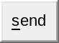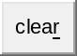
Bottom of Form

2) User defined buttons: -
<input type=”button” value=”-----”>
Ex: -
<input type=“button” value=“My button”>

Designing the above form programs: -
<html>
<head>
<title> forms table</title>
</head>
<body text="#ffc800">
<form name="Sudheer" action="Sunil" method="get">
<center>
<table border="10" cellspacing="2"cellpadding="2"bgcolor="green">
<tr align="center">
<th colspan="2">forms table</th>
</tr>
<tr>
<td> name : </td>
<td> <input type="text" name="sname" value="" size="30" maxlength ="20"> </td>
</tr>
<tr>
<td> password : </td>
<td><input type="password" name="sno" value=""></td>
</tr>
<tr>
<td> re enter password : </td>
<td><input type="password="sno" value=""></td>
</tr>
<tr>
<td> Gender : </td>
<td> Male<input type="radio" name="sex" value="male" checked>
Female<input type="radio" name="sex" value="female" > </td>
</tr>
<tr>
<td>offered courses : </td>
<td> <input type="checkbox" name="crs1"value="C"> C Lang
<input type="checkbox" name="crs2"value="CPP"> CPP Lang
<input type="checkbox" name="crs3"value="java"> Java Lang
<input type="checkbox" name="crs4"value=".net"> .net Lang</td>
</tr>
<tr>
<td> qualification : </td>
<td> <select name="qual">
<option> M.C.A
<option> M.Sc
<option> M.A
<option> M.B.A
<option> B.A
<option> M.com
<option> B.com
<option> M.Sc
</select></td>
</tr>
<tr>
<td> address : </td>
<td> <textarea rows="10"cols="30"name="address">
</textarea></td>
</tr>
<tr align="center">
<td> <input type="submit" value="send"></td>
<td> <input type="reset" value="clear"></td>
</tr>
</table>
</center>
</form>
</body>
</html>

O/P: -

forms table
name :
password : | 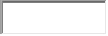
re enter password :
Gender : | Male Female
offered courses : | C Lang CPP Lang Java Lang .net Lang
qualification :
address :

